**E-Thesis Submission Process**

**STEP 1: STUDENT-INSTITUTE COORDINATION**



  
 Student

1. After the thesis format approval, the student obtains signatures from at least two copies of the printed and bound thesis, including the thesis committee members and, if applicable, the co-supervisor. The student then signs these copies and submits them to the Institute.

2. The student signs the "Publication, Intellectual Property Rights, and Accuracy Declaration."

3. The student uploads the PDF of the thesis, which must be identical in format, content, page numbering, etc., to the printed and bound version submitted to the Institute. This PDF must also include metadata matching the printed version. In compliance with the Personal Data Protection Law No. 6698, personal information (such as ID, phone number, address, marital status, email, etc.) must not be included in the PDF content.

4. Upon approval of the thesis, the student completes the thesis submission process by submitting the YÖK Data Entry Form.

**STEP 2: INSTITUTE PROCESS**

 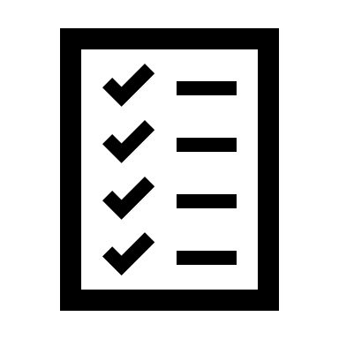

Institute

1. The thesis uploaded by the student is assigned to the Institute coordinator's OpenMETU task pool.

2. The Institute coordinator compares the printed thesis with the version uploaded to OpenMETU and approves it if they are identical.

*If the thesis is restricted from access, the coordinator will restrict the access to the PDF on OpenMETU before the approval process and will send the access restriction decision to library via the EBYS system.

3. Chairman of the department and the Institute director sign the printed thesis.

4. The Institute coordinator scans the printed thesis' jury signature page, the page signed by the student immediately after the jury signature page, and the "Publication, Intellectual Property Rights, and Accuracy Declaration," and sends them as a single PDF to library via the EBYS system.

5. The Institute coordinator uploads the PDF to the YÖK National Thesis Center.

Coordinator

**STEP 3: LIBRARY PROCESS**

 

1. The Library coordinator uploads the signed PDF file sent via EBYS as the second PDF file to the thesis record *(the pages with wet signatures will remain permanently restricted from access).*

2. The Library ensures the OpenMETU PDF, metadata, and access controls for the theses approved by the Institute.

3. The Library sends the approval email to the Institute.

4. The thesis is added to the OpenMETU repository.

5. The Library creates the catalog record for the thesis in the library automation system.

Library

Coordinator

**REQUEST FOR CHANGES TO APPROVED THESIS**

 

In case a student requests changes to the metadata and/or PDF file of the thesis that has been approved and added to the OpenMETU repository:

1. Change requests will only be considered by the institutes in exceptional circumstances. The requested changes must be submitted to the relevant Institute with a formal petition, specifying the changes in the OpenMETU metadata and/or the page numbers of the PDF, along with a justification for the changes.

2. If the Institute approves the changes, they will forward the approval to the library via EBYS with a cover letter.

3. Library will make the necessary changes on OpenMETU and inform the relevant Institute through EBYS.

Student,

Institute Coordinator,

Library Coordinator